**Chess**

Simple chess game created with python in pygame framework. Game is played human vs human.

**Prerequisites**

* Python 3.6.6
* pygame 1.9.5

**Installing**

Download repositry, open comand prompt, navigate to downloaded repository and run:

python ChessBoard.py

**Gameplay**

Click on the piece than again on the desired location to move the piece. Possibilities where piece can move are shown with grey dot.

[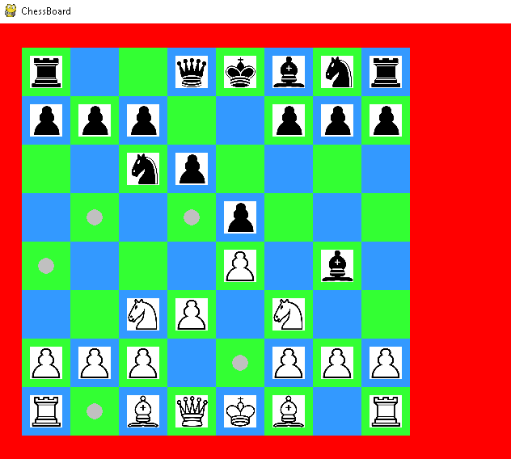](https://github.com/JernejHenigman/Chess/blob/master/chess_board2.png)

**Built With**

* [pygame](https://www.pygame.org/) - The game framework